** **

**UNIVERSITY INSTITUTE OF ENGINEERING**

**Department of Computer Science & Engineering**

**(BE-CSE/IT-5th Sem)**



**Subject Name: AP LAB-II**

**Subject Code: 22CSP-351**

**Submitted to: Submitted by:**

Faculty name Name: Ankit Kharb

Bhumika UID: 22BCS16964

Section: 22BCS-IOT-614

Group: B

**Question 1.** Implement Queue Using Stack

**CODE:**

**OUTPUT:**

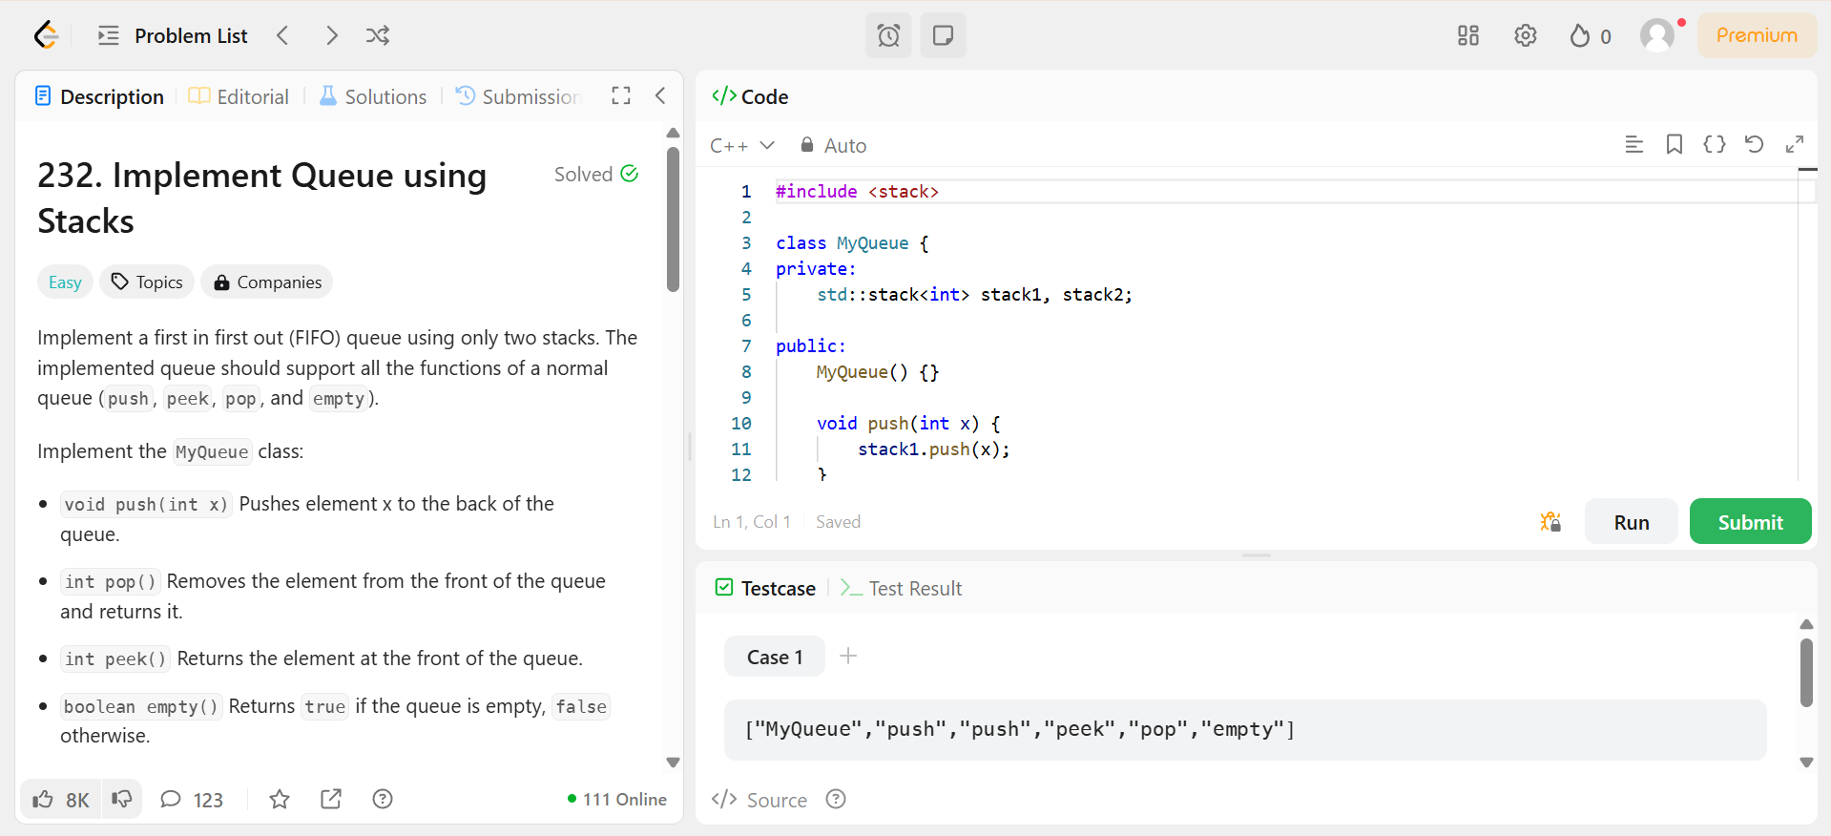

**Question 2:** Min Stack

**CODE:**

**OUTPUT:**

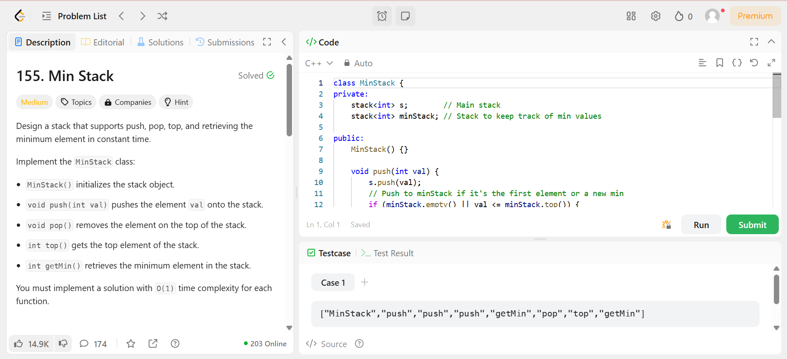

**Question 3:** Implement Stack Using Queues

**CODE:**

**OUTPUT:**

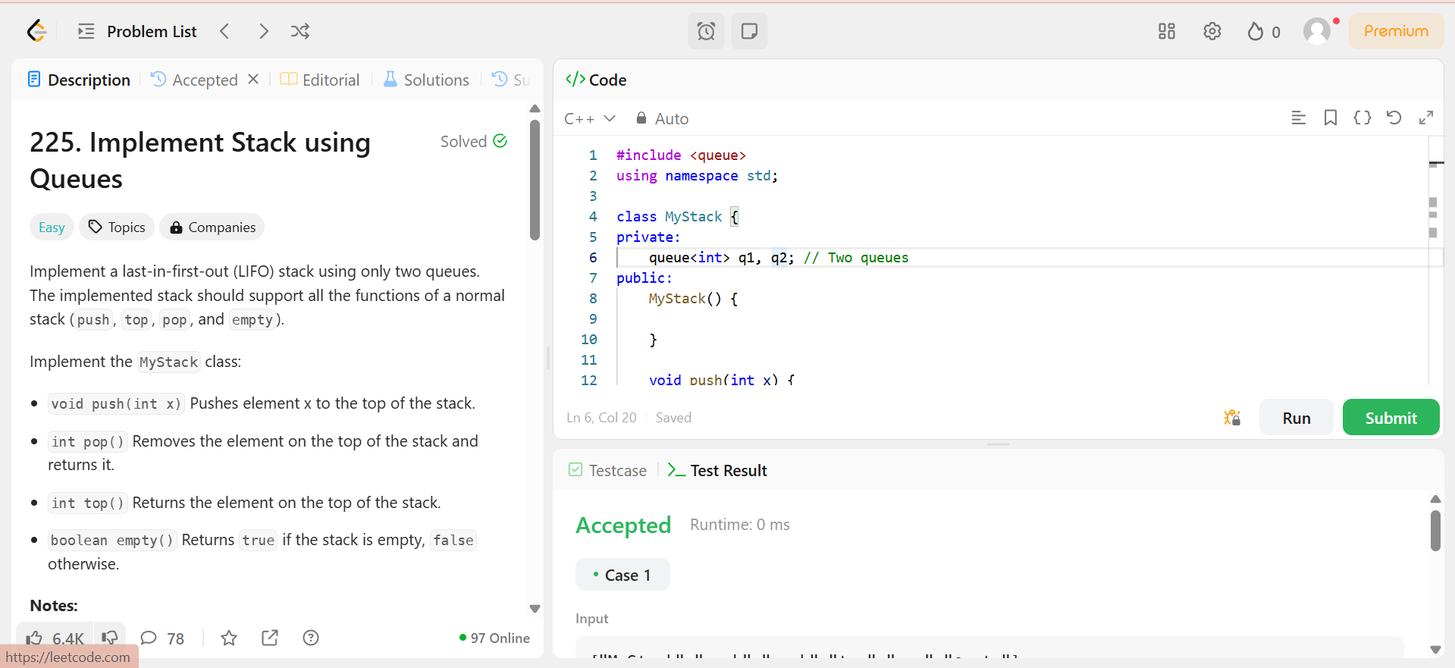

**Question 4:** Design circular queue

**CODE:**

**OUTPUT:**

